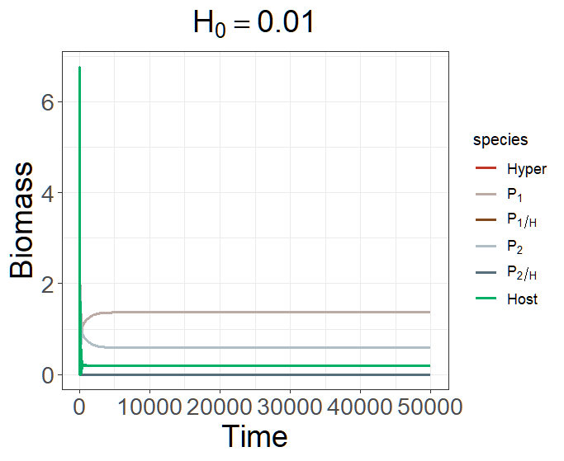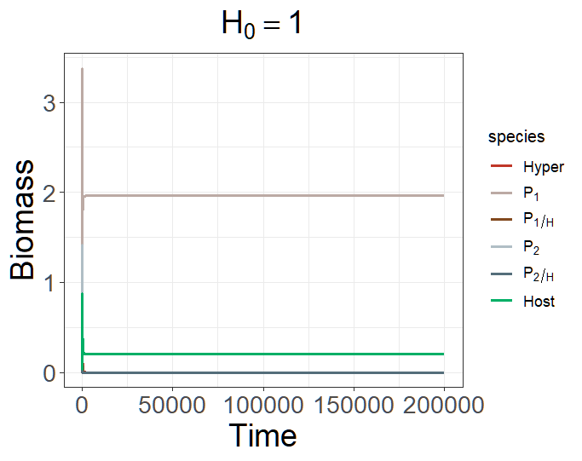
state <- c(H = 0.01/1, P1H = 0, P2H = 0, P1 = 0.01, P2 = 0.01, S = 0.2)
parms <- c(r = 1, K = 10,
+ a1 = 0.5, a2 = 0.5, R1 = 1, R2 = 1, e1 = 0.5, e2 = 0.5,
+ b1 = 0.3, b2 = 0.45, m1 = 0.05, m2 = 0.05, e1H = 0.5, e2H = 0.5,
+ o1 = 0.8, o2 = 0.8, h1 = 1, h2 = 1, c1 = 0.9, c2 = 0.9, d = 0.03, DL = 0)

Alternative stable state -> actually is not like alternative stable state, 因為只是兩條 isoclines 重疊
When H is large, and α1 = α2, P2 will be excluded because H is too large.

Try a single-strain model to test the condition in which the hyperparasite can persist in the system:

Fix α = 0.5, and change β to see in which situation H can persist.
在 single species 的model 中可知道， when α = 0.5, β < = 0.35, H cannot persist.
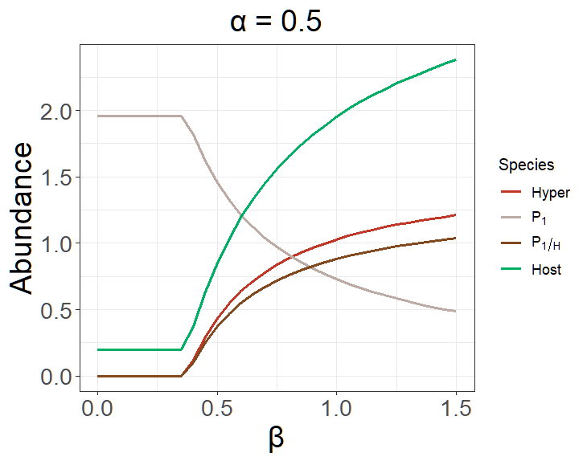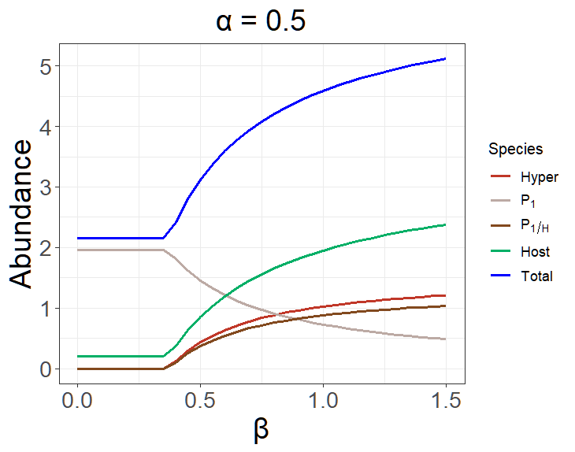
times <- seq(0, 20000, by = 0.1)
state <- c(H = 0.01, P1H = 0, P1 = 0.01, S = 0.2)
parms <- c(r = 1, K = 10,
a1 = 0.5, psi1 = 1, e1 = 0.5,
b1 = 0.35, m1 = 0.05, e1H = 0.5,
o1 = 0.8, h1 = 1, c1 = 0.9, d = 0.03, DL = 0)

There is no priority effect in the current parameter set.
According to the results of Pre1Sim1N, when α₁ = α₂ = 0.5, H cannot persist until β₁ = 0.4 and β₂ = 0.45, which might imply that there should be at least one strain can support H persist that H can persist in the system with two different strains.
If H can persist, then there will be no priority effect.
If H cannot persist, there will possibly be a priority effect, e.g., when α₁ = α₂ = 0.5 and β₁ < 0.4, but it is not deterministic, e.g. when α₁ > α₂. (See the area that only P₁ wins)

為什麼 H 增加的幅度會趨近飽和？
When can another strain invade the system, and will H be excluded due to the invasion of another strain?

Based on epidemiology, an increase in the mortality of a pathogen may increase its performance, making it more competitive.
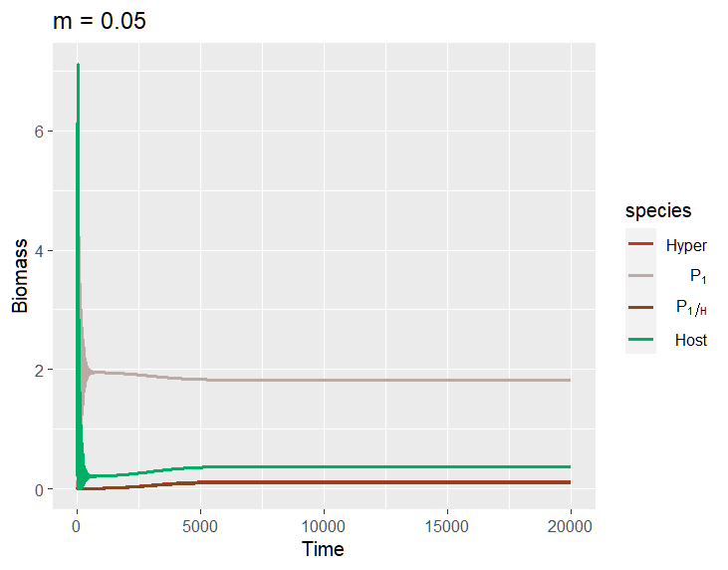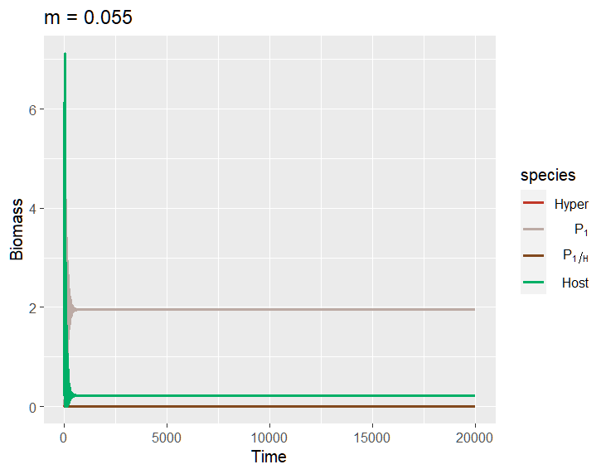
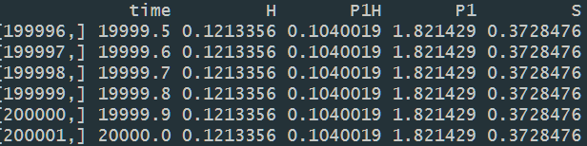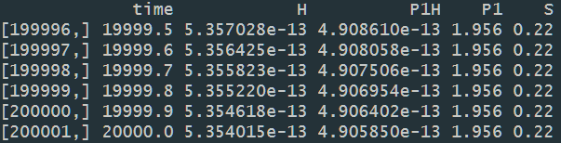

Both the abundance of hyperparasite and hyperparasited pathogen dramatically decreases, which is predictable because hyperparasited pathogen will have fewer chances to survive and will affect its contribution to hyperparasite.

However, it turns out that an increase in the pathogen's mortality will increase its total abundance.
When m = 0.05, the total abundance is 1.9254309.
When m = 0.055, the total abundance is 1.956, approximately equal to the system without H (1.96).
I think it is primarily because of the decrease of hyperparasite, though.

可作圖，x軸為m、y軸為equilibrium abundance of pathogen.
或heat map: y -> m2, x -> m1, z -> competition outcome.

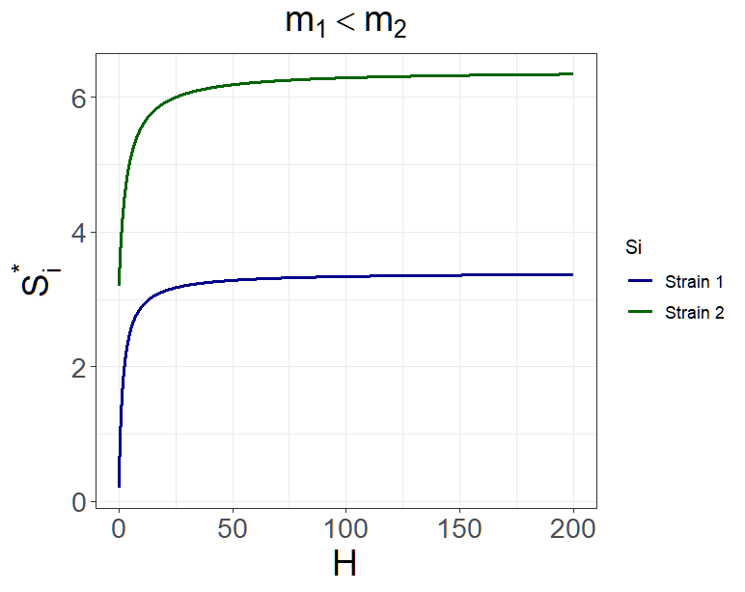
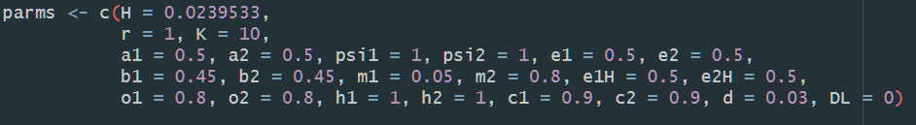

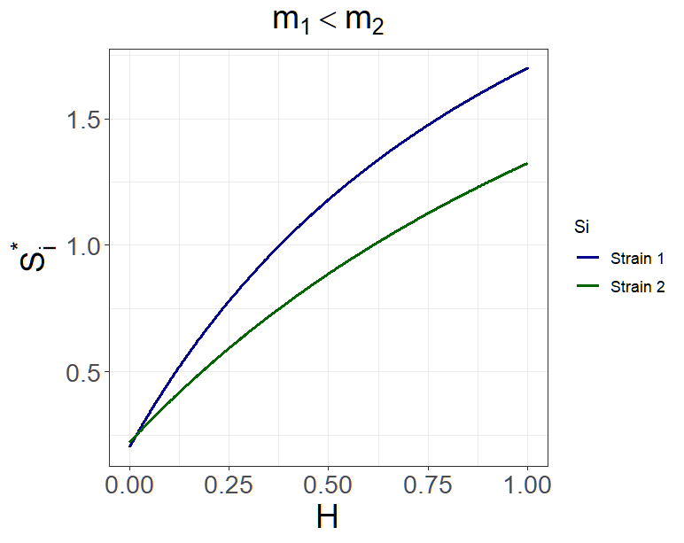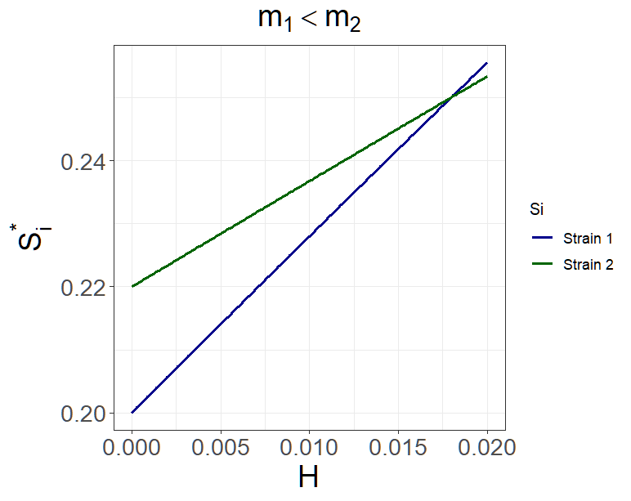
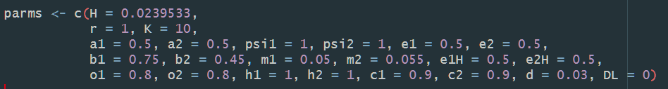
Compare with the original model?

